Formation of Rains

Book recommendations (for extensions):
National Geographic Kids Ultimate Weatherpedia
DK Eyewitness books: Weather

MATERIALS:
- hair dryer
- glass bowl
- a small pitcher with water
- chart 23a

PRESENTATION:
- Do you remember that at sea level it was more difficult for heat to escape, because of the density of the layers of air (or atmosphere)? Do you remember that we said that as we moved up the mountain the layers of air got thinner and thinner, which made it colder at the top of the mountain than at sea level?
- Did you also know that when air is heated, it picks up a lot of moisture?
- Pour a few drops of water in the bowl and spread it around.
- Plug in the blow dryer. It represents our hot air.
- Point the blow dryer into the bowl and leave it there until the water evaporates.
- Show the dry bowl and ask: Where did all the water go?
- Heated air picks up water. For instance, when air travels over the water, it picks up moisture.
- Show chart 23a.
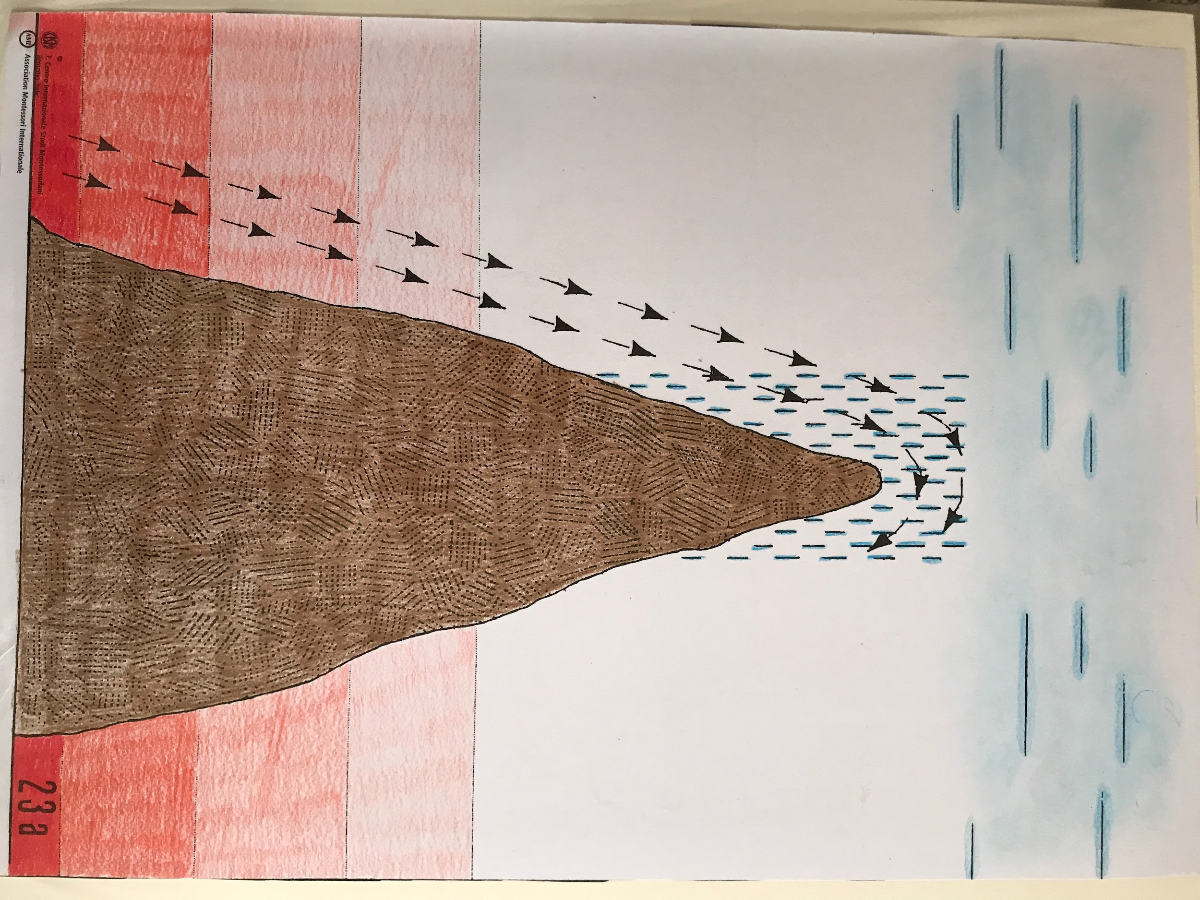
- This chart illustrates what we learned about in the Story of Life. Air carries water along, and then when the water gets too heavy air has to drop it. It’s as if water were stepping onto a carriage, which is air, and were going for a ride.
- In this chart, warm air is flowing along near the surface of the Earth, picking up water. When air reaches a mountain or high land, it is forced to travel upwards. We know that the region gets colder and colder the further up we go. Therefore, as air travels upwards it gets colder, too. It cannot hold its moisture so it drops it.
  - Note: This can be illustrated by putting hot water in a bowl and covering it with a cold dish/lid. The water will evaporate but will condensate on the cold dish/lid.
- Maybe by the time the air has reached the top of this mountain, it will have dropped a lot of its moisture. Therefore, sometimes in places like this we will have rain on one side of the mountain but not on the other. We say that on the dry side there is a “rain shadow”.
- This type of rain is called orographic rain. Oro- comes from Greek oros, meaning “mountain”.

Following Explorations:
- The children can study rain and precipitation in general.
- They can also look at where we find rain shadows on the earth (Andes, Rocky Mountains, etc.) They can find this out by exploring the type of vegetation found on each side of the mountain.
- Children can also study different types of clouds.

